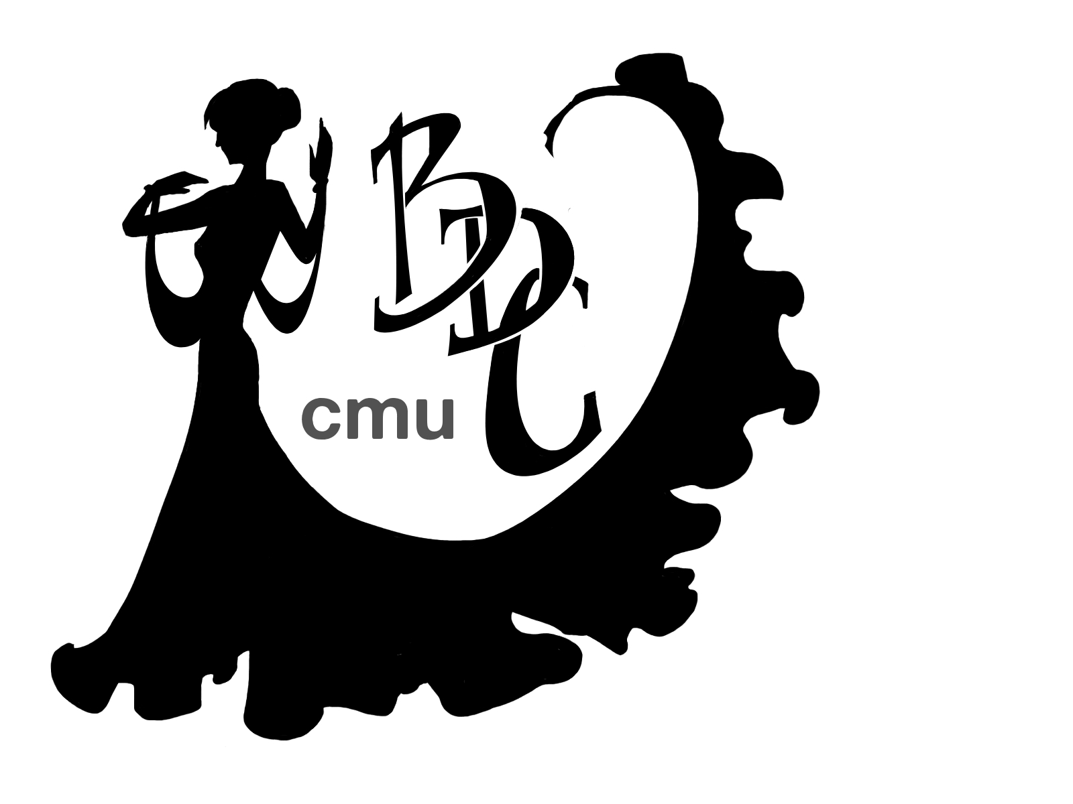
Why Be an Officer?
Officers are an integral part of the club—as an officer you have the chance to influence everything about how the club runs, from what we teach at lessons, what lessons we offer at different levels, what fun events we have, competitions that we go to, publicity efforts on campus and throughout Pittsburgh, designing our website and more! Additionally, all officers receive reduced membership and other benefits during their term. It is also a perfect opportunity to practice skills such as leadership, organization, communication, and really impact the CMU campus as well as the Pittsburgh community!
ALL positions are open for election. A list of all the positions along with their descriptions can be found further in the document. If there is a position you are interested in – go for it! If you are currently an officer and would like you retain your position, you need to reapply and be reelected. Application guidelines and description of the election process can be found below.
Application Process
Please e-mail your answers to the below questions to ballroom@andrew.cmu.edu by Monday, March 16 at NOON (12 PM) with Subject line: Ballroom Officer Application 2014
- Your name
- Preferred e-mail
- Phone number
- Major and year (if applicable)
- Time in club (ex: 1 semester; 1 year)
- Positions running for (max 3, list in order of preference)
- Other extracurricular commitments you have
You must then attend the election on Monday, March 24, at 9:15PM (arrive 10 minutes early). If you want to run for a position but are unable to be there on the day of the elections or for a particular time, please let us know and we will try to make arrangements. You may elect to have a proxy speak on your behalf.
Election Process
We will be holding elections on MONDAY, MARCH 24, at 9:40 PM in McConomy Auditorium. There will be NO Open Floor at this time. All CMUBDC membership cardholders are eligible to run for positions and vote, and we encourage you all to attend! The election process will go as follows:
- Each candidate for a position will give a 30-45 second speech on why they want the position and be questioned for 2-5 minutes by the panel (open to any person who has a ballroom membership card). Other candidates for the position will be outside the room during this process.
- After going through each candidate, the panel will deliberate and cast ballots for their choice.
- Move on to the next position.
- All votes will be tabulated at the end of the election. Results will be announced within 48 hours

When giving your speech, consider the following questions:
- Why do you want to be a BDC Officer? Why that particular position?
- Why would you be a good officer in general? How would you describe your communication style?
- What recent leadership experiences do you have?
- What other extracurricular activities that you plan to do next year/how much can you commit?
- How would you improve the Ballroom Dance Club overall? What would you do in your position specifically?
Available Positions
- President
  - Job: Having a vision for the club and understanding the “big picture,” while ensuring that the club functions smoothly by facilitating cohesive work by other officers. Processing/delegation of all internal and external communication. Running meetings, delegating tasks, motivating the other officers.
  - Ideal Skills: Leadership, communication, organization, multitasking, delegation, time management, people skills, conflict resolution, motivation, public speaking, attention to detail, and big picture vision. Ability to keep track of everything that goes on in the club.

- Competition Team Captain
  - Job: Encouraging dancers to compete and preparing them for competition. Scheduling, planning, and running practices, rounds, and mock competition for team members. The Captain should be present at all practices and actively attend competitions, where he/she will provide moral support and encouragement for the team. Facilitating a team environment through organizing bonding activities. The Captain should take part assisting the Lessons Coordinators in planning of workshops. The Captain is responsible for ordering and organizing the jacket orders. NOTE: In the absence of Team Manager at any competition, the Captain should perform the Manager’s duties as well.
  - Ideal Skills: Communication and people skills, as well as having an encouraging and supportive spirit. Must understand the structure of ballroom competitions, and have the desire to improve overall team results as well as each member’s competition experience. Preferably an advanced dancer. Will work closely with the Competition Team Manager

- Competition Team Manager
  - Job: Preparing logistics for competitions: registration, transportation, and housing. Should attend all competitions and be the point of contact for team members, ensuring that registration, transportation, and housing matters are running smoothly. Minimize team expenses and work closely with the treasurer to ensure staying within budget.
  - Ideal Skills: Organization, communication, adherence to deadlines, attention to detail, multitasking. Being a smart shopper will greatly benefit the club financially.

- Treasurer
  - Job: Creating and keeping track of the budget for the club each year. Throughout the year, allocating funds to all club activities and working closely with officers who spend money. Maintaining a detailed record of our revenue and expenses. Monthly responsibilities include paying instructors, depositing earnings, and submitting reimbursement forms. Must attend Joint Funding Committee training and information sessions, as well as the Authorized Signer training. Is responsible for working with the JFC for special allocations and budget appeals.
  - Ideal Skills: Organization, good with Excel and numbers, adherence to deadlines, big picture thinking, communication, multitasking, excellent record-keeping.

- Lessons Coordinator
  - Job: Creating and maintaining a schedule of lessons, instructors, tablers, including contacting and scheduling professional instructors. Ensuring that our weekly operations run smoothly. Schedule and organize professional workshops.
  - Ideal Skills: Organization, communication, people skills, adherence to deadlines, adaptability. Vision for optimal lesson structure for maximum club and competition team benefits.

- Events Coordinator - Internal
  - Job: Planning and executing events for club members and the Pittsburgh community, including Rush, Dancing With The Stars – CMU Edition, Scotch Ball, Late Night events, and socials. The Internal coordinator is responsible for planning the schedule of the event, organizing activities and performances, assigning officer roles, and setup and cleanup, and other tasks necessary for successful event organization, NOTE: Must work closely with the External coordinator and assist with their tasks as necessary.
  - Ideal Skills: Organization, time management, communication, creativity, multitasking.

- Events Coordinator – External
  - Job: Planning and executing events for club members and the Pittsburgh community, including Rush, Dancing With The Stars – CMU Edition, Scotch Ball, Late Night events, and socials. The External coordinator is responsible for making purchases of food, drinks, and decorations, contacting and contracting venues and caterers, obtaining sponsorship. NOTE: Must work closely with the Internal coordinator and assist with their tasks as necessary.
  - Ideal Skills: Organization, time management, communication, creativity, multitasking.

- Public Relations Coordinator
  - Job: Advertising of special events and the club as a whole on campus, on the web/social media, and throughout Pittsburgh. Club lessons, salsa lessons, club socials, Rush, annual Fall and Spring events, Late Nights, and all other events must be advertised. Utilize all the methods available, such as postering, mailing lists, Facebook, chalking, postcards, word of mouth, and others. NOTE: Artwork could be either done by the officer, or outsourced.
  - Ideal Skills: Adherence to deadlines, time management, communication, people skills, creativity, enthusiasm, diligence.

- Secretary
  - Job: Maintaining schedule and calendar, and keeping the club members informed about individual lessons and special events. Updating membership information and club e-mail lists. Reserving rooms for lessons, events, and practice space. Providing organizational support to other officers as needed.
  - Ideal Skills: Organization, communication, adherence to deadlines.

- Media Manager
  - Job: Maintaining all the media of the club, including music, videos, photos, and the website. Responsible for safekeeping of the video camera. Recording and uploading videos of team rounds and performances, creating music playlists for practices and events. Maintaining the website with up-to-date information. NOTE: Website can either be maintained by the officer, or outsourced.
  - Ideal Skills: Organization, multi-tasking, reliability, time management.
We are also looking for designers and webmasters! Throughout the semester we need to have advertising materials designed, website updated, and other tasks that require specific artistic skills. These will not be officer positions, but you will be contacted once in a while with assignments. If you are interested, please email ballroom@andrew.cmu.edu with the subject “Designer [or Webmaster] interest.” Thanks!

ALL OFFICERS are expected to also complete the following duties: teaching lessons, tabling during lessons, room set up and clean up, assisting with running of events, contributing to advertising efforts, as well as other club needs. All the officers must be trustworthy, reliable, and responsible people who can get along with each other and are passionate about the club and the happiness of its members.
NOTE: Our club is large and has a lot of things going on, so being an officer is a very time-consuming task. If you are a student, however, your schoolwork should be your first priority. We don’t want your grades suffering, so please make sure you are ready for the work you are taking on. (It is recommended that you have a 3.0+ GPA prior to applying, but is not a requirement.)

To learn more about any position, talk to the officer currently in the position or Helen.
Newly elected officers will be “in-training” during the Spring 2014 semester.

