Submitting a Java NetBeans Project
We will be using the NetBeans Export Project function to export and submit a project ZIP file.
Click on the File tab within NetBeans and choose Export Project. Click on To ZIP…
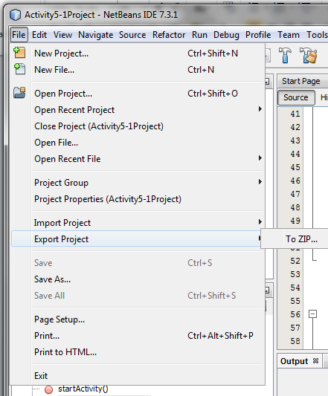
Notice that NetBeans tries to put the export in the Temp directory. The AppData directory is hidden so you can’t see the project if you search for it You can browse for a different directory
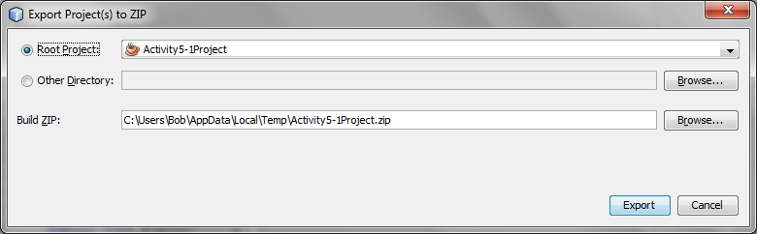

When you do so NetBeans (very unfriendly) removes the project name and defaults to “All Files”:
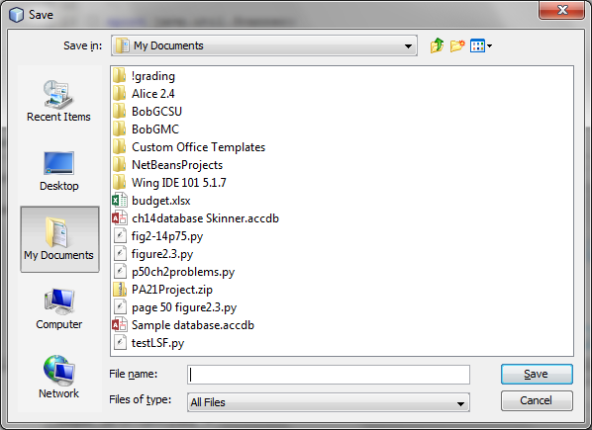
Just navigate to where you want to save then re-enter the name. Be sure to add the extension .zip
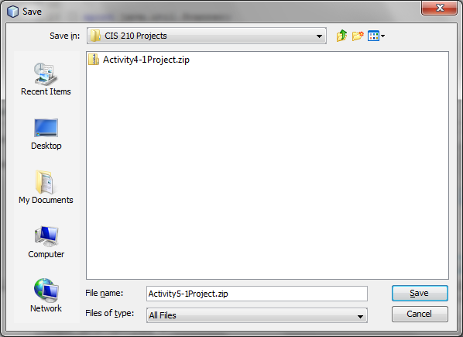

And export the file
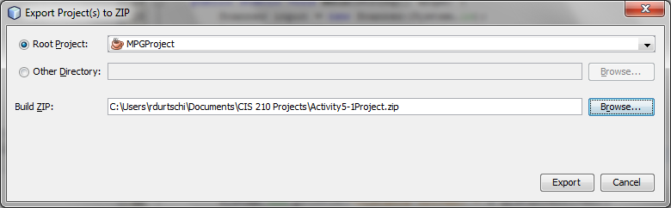

A file manager window may pop up with the project folder inside of project.zip.
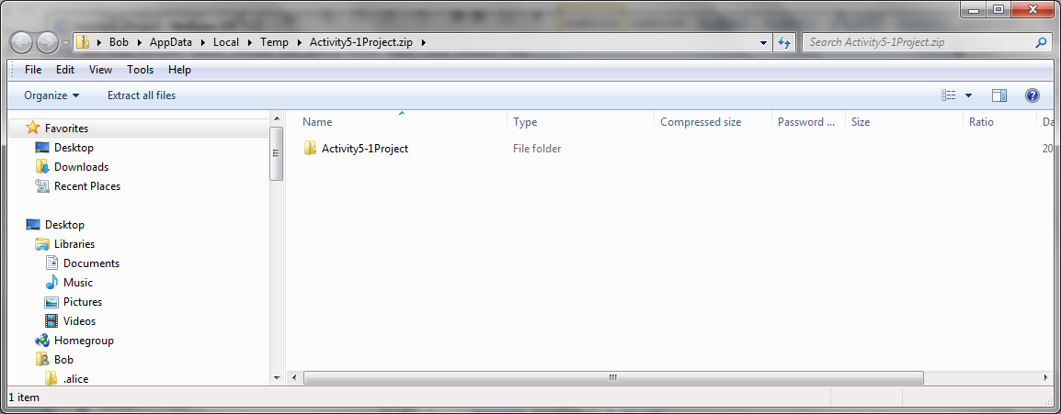
Just ignore that and navigate up one level to where you saved the zip file.
Then upload it to the Moodle project submission area.

