Creating a NetBeans Project from Existing Sources
The Programming Activity examples from the book require you to edit the files that are provided in the exercise. In order to do that in NetBeans, it is necessary to create the project from existing sources.
Select File -> New Project from the main menu. Choose the Java category and the Java Project with Existing Sources project type.
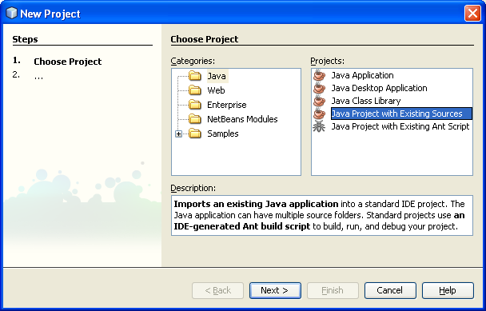
Select Next. Enter the name for the project. I suggest that you include the word project in the name. For instance, if this is from Chapter3 Example 3.1 of the book, then name the project Example3-1Project.
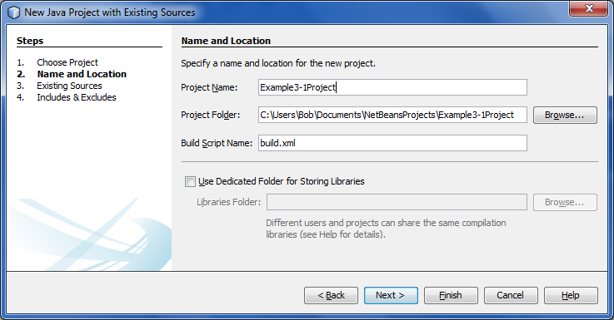
Select Next. Click on the Add Folder button then browse to the folder that contains the source files. In this example “SimpleDate files” in the “NetBeansProjects” folder
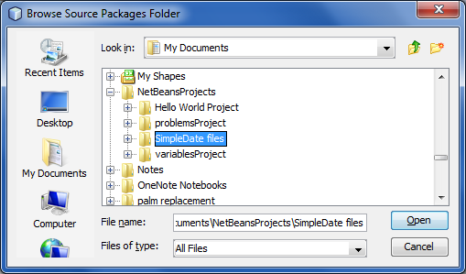
Do not double-click to open the folder, just select it.
Click Open; you will be returned to the wizard.
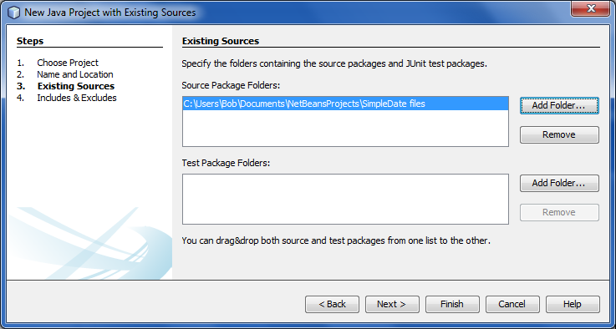

Select Next. You will see the list of files that are to be added. You only have to click Finish on this page, but take a moment to see if the correct files are being added.
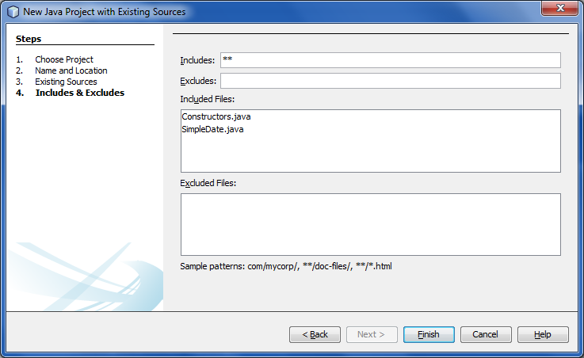
Click Finish. You will be returned to the NetBeans window. Click on the plus to the left of “default packages” to see the files that have been added to your project. In this example, two files have been added to the default package. For now, all files will be in the default package. Later in the course you will learn how to use packages to organize your source code.
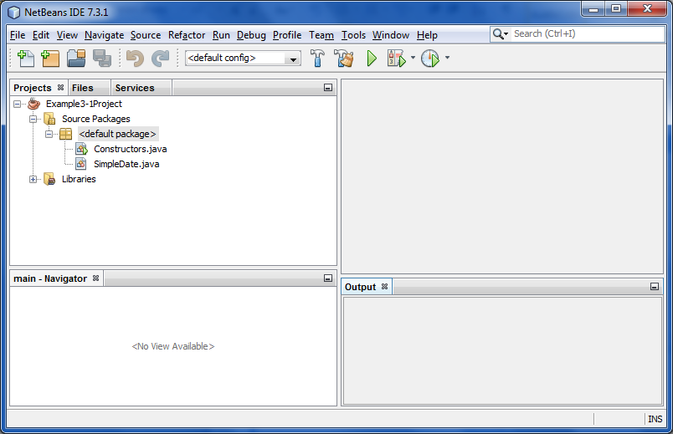

Double-click the Constructor.java file. It will open in the editor pane. There is also a list of methods for this class shown in the class Navigator pane.
This is where you will make changes to the file.
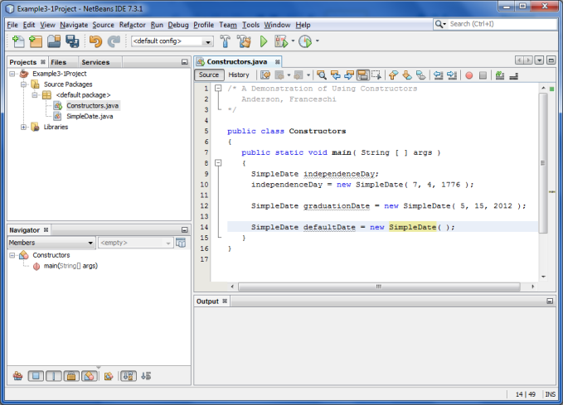

Once you have made changes, open the Run menu and select Run Project (top selection).
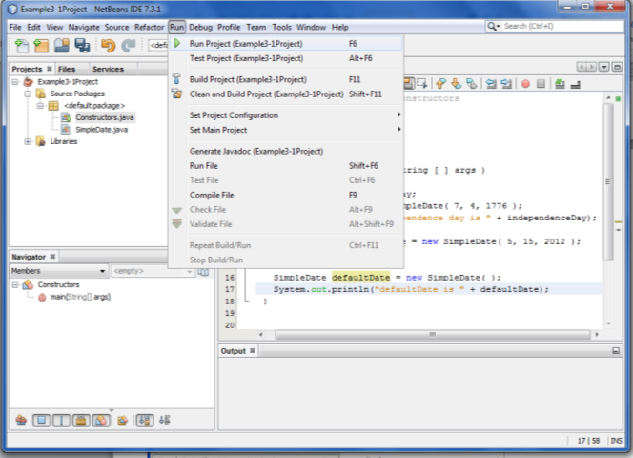
The project does not know which file contains the main method that starts the application, so it gives you a list of all the files that contain a main method. In this example, there is only one file with a main method. Select that file and click OK.
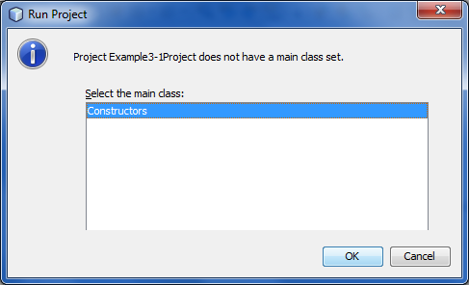
The application starts to run.

