NetBeans First Project
When you first start NetBeans: Learn and Discover tab. Click on Java SE Application under Demos & Tutorials
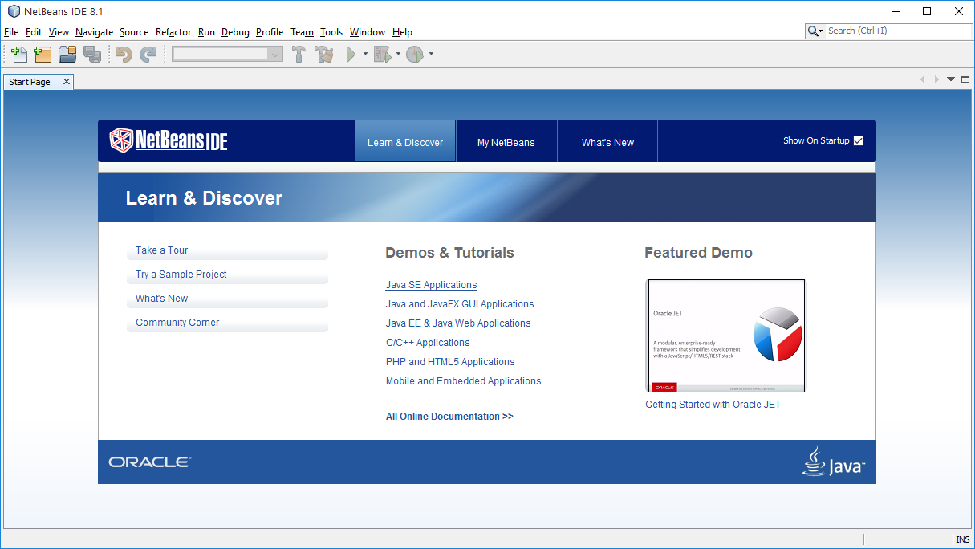
Brings up the webpage https://netbeans.org/kb/docs/java/quickstart.html
Note: if you do not see the start page you can go directly to the quick start by clicking on the above link
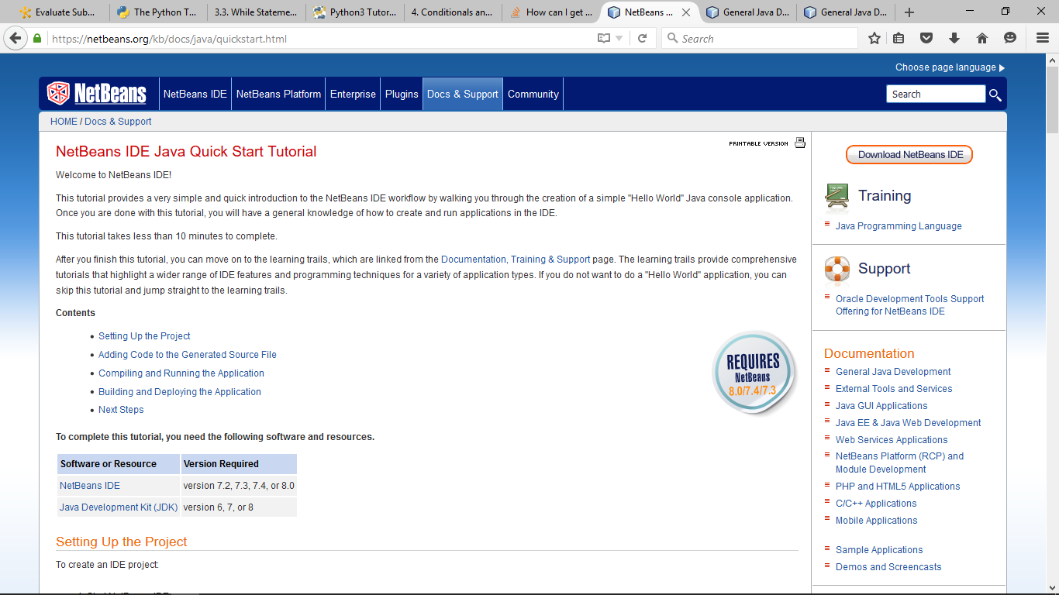
Step 4 of the tutorial: Instead of calling your project "HelloWorldApp" call it "HelloWorldProject":
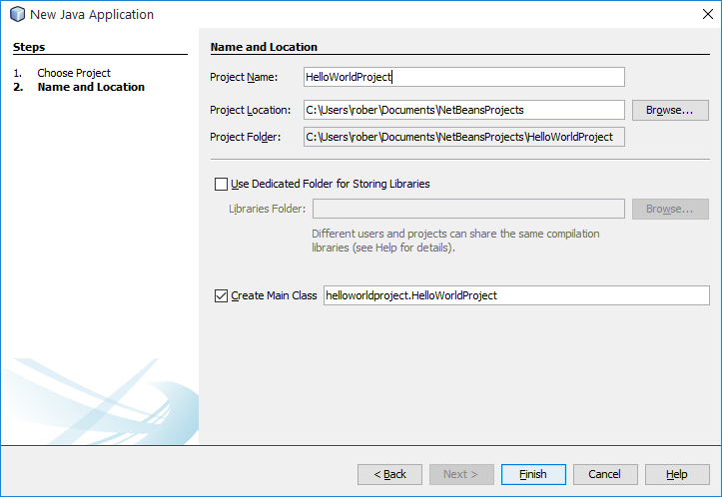
NetBeans will automatically set the Main Class to " helloworldproject.HelloWorldProject"
Click Finish:
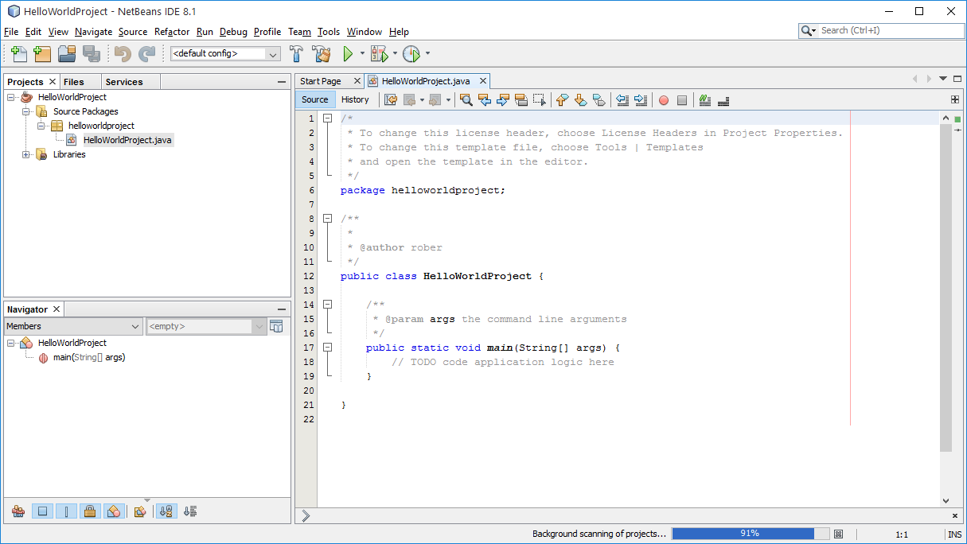
You can copy/paste the System.out.println("Hello World!"); from the tutorial over the top of the "todo line"

You can run the project by clicking Run > Run Project. OR clicking on the green arrow at the top of the project window

NOTE: The folder NetBeansProjects is automatically created on your computer:
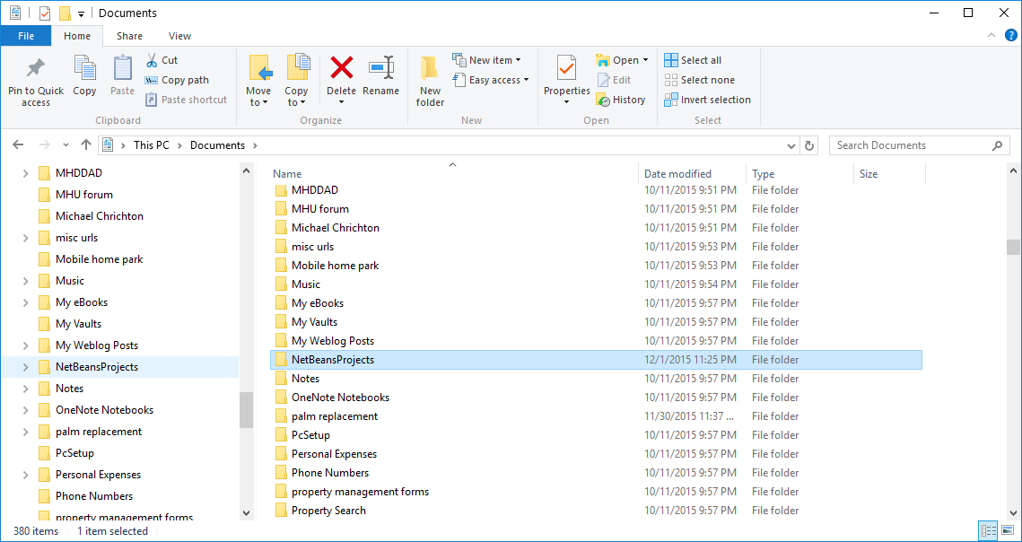

Do follow the steps to build your application: Choose Run > Clean and Build Project.

Follow the instructions in Submitting a Java NetBeans Project to create a NetBeans project .ZIP file and submit it for the project

