Installing JDK (Java Development Kit) and NetBeans IDE
as of Dec 2015

http://www.oracle.com/technetwork/java/javase/downloads/index.html
Click on the NetBeans button
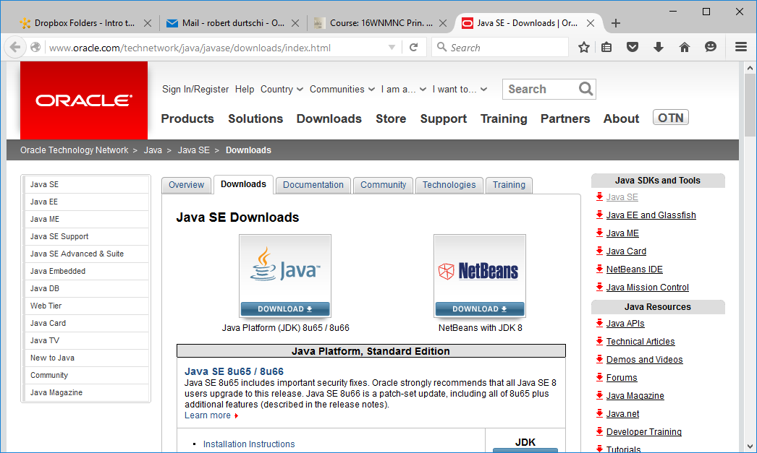
Click on Accept radio button
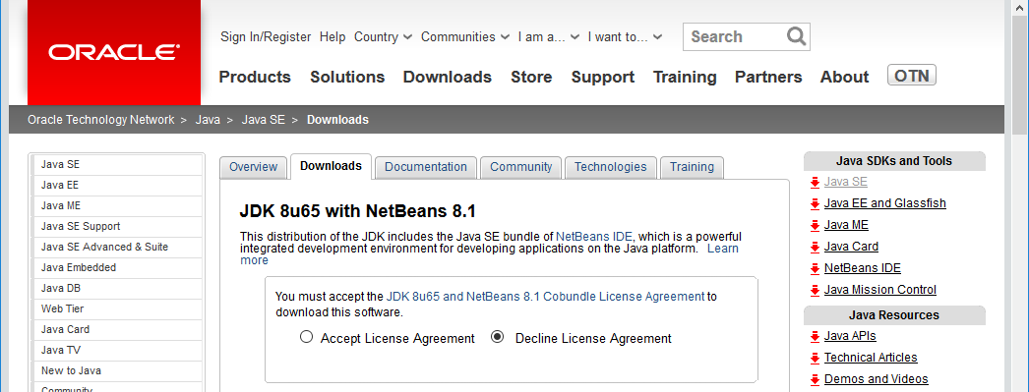

That changes to Thankyou …. There are now two Linux versions, one Mac version, and two Windows versions
For Windows: Even though your version of Windows is 64-bit (X64) the 32 bit version will work just fine.
It may be a bit slower, but for the level we will get into it should not matter. Click on jdk-8u65-nb-8_1-windows-i586.exe
A download window pops up:
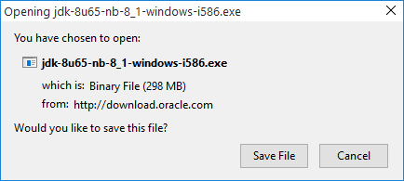
Click 0n: Save File. Then choose where to download. I chose "downloads":
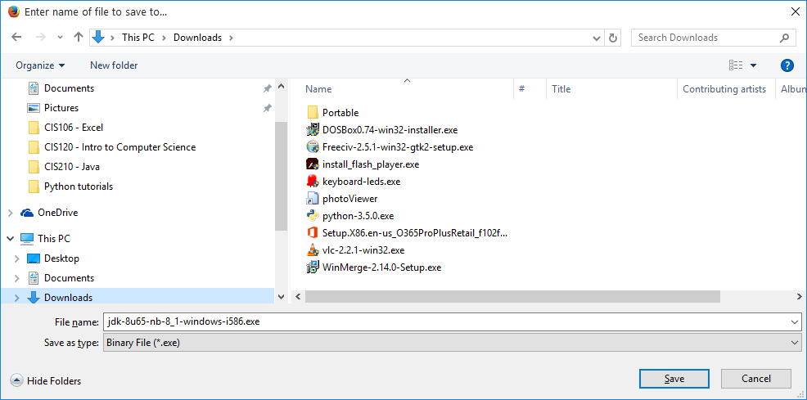
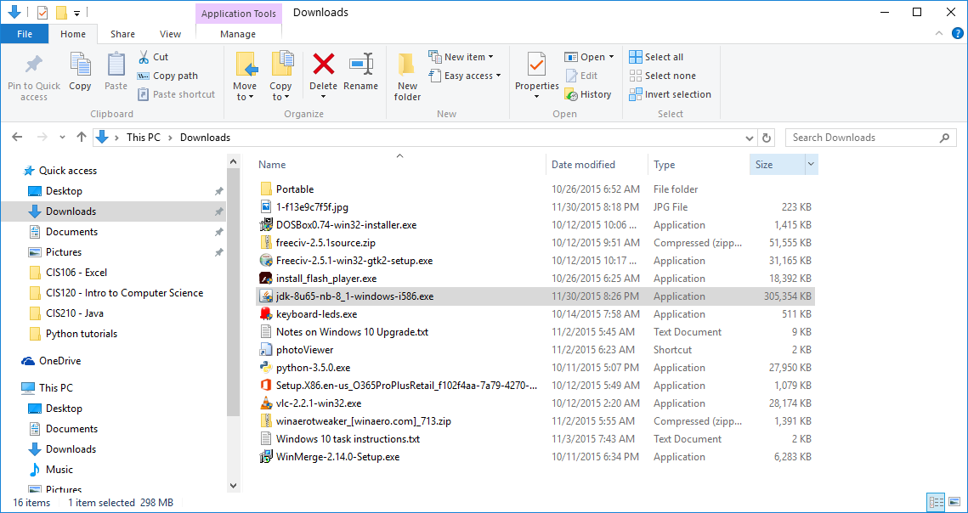
After the download finishes navigate to where you downloaded and Double click on installation file.
When asked if you want to make changes to your system, click yes

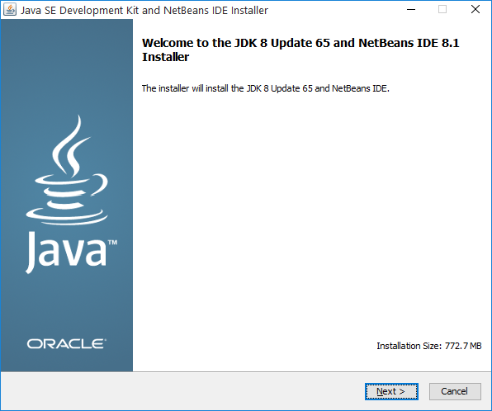
Click Next
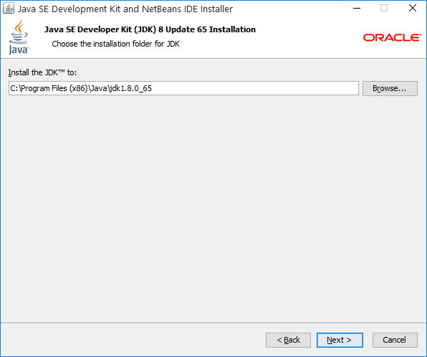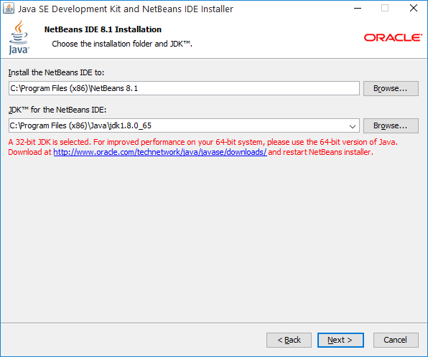
Click Next Ignore the warning about 32 bit Java on a 64 bit computer. Next

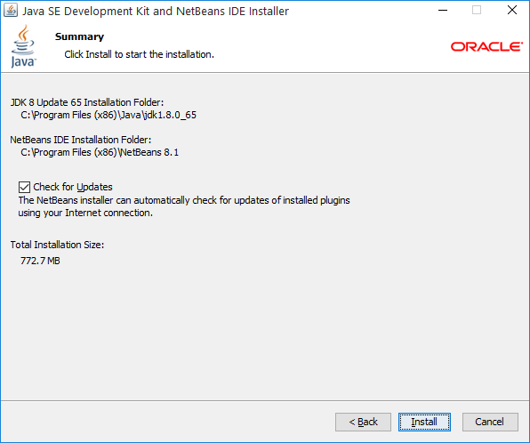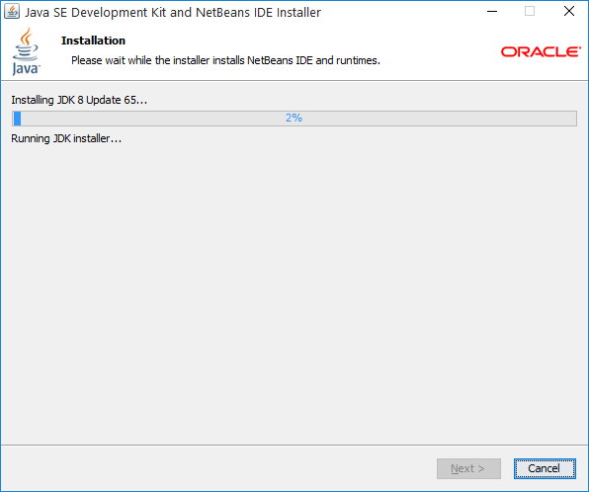
Click Install A progress window will appear
Be patient it will take a while to extract all of the files
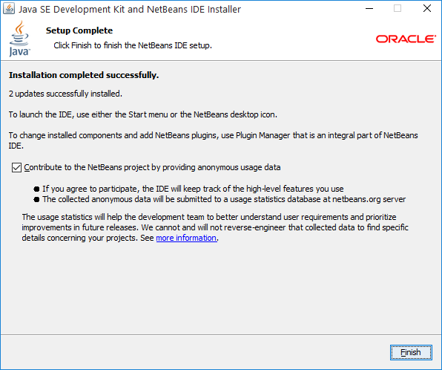

NetBeans Icon shows up on your desktop
