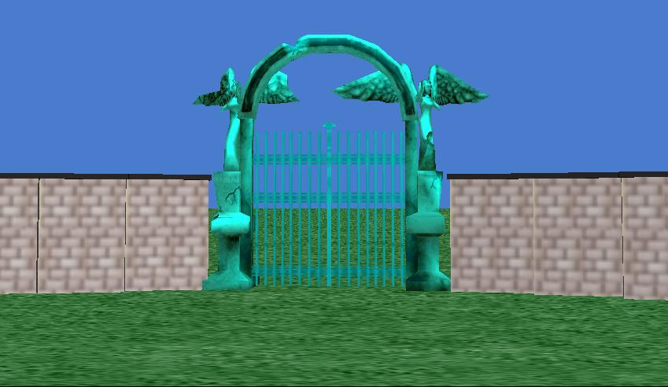
Fall Semester 2012
Team Members:

